https://shorturl.at/kAHNV

**\*\*\*\*\*\*\*\*\*\*\*\*\*\*\*\*\*\*\*\*\*\*\*\*\*\*\*\*\*\*\*\*\*\*\*\*\*\*\*\*\*\*\*\*\*\*\*\*\*\*\*\*\*\*\*\*\*\*\*\*\*\*\*\*\*\*\*\*\*\*\*\*\*\*\*\*\*\*\*\*\*\***

**Bootstrap intro**

**Colors**

**Modal**

**Lists**

**Tables**

**Input groups**

**\*\*\*\*\*\*\*\*\*\*\*\*\*\*\*\*\*\*\*\*\*\*\*\*\*\*\*\*\*\*\*\*\*\*\*\*\*\*\*\*\*\*\*\*\*\*\*\*\*\*\*\*\*\*\*\*\*\*\*\*\*\*\*\*\*\*\*\*\*\*\*\*\*\*\*\*\*\*\*\*\*\***

Bootstrap

- Bootstrap is opensource framework of CSS.

- It helps in designing responsive and device

friendly web pages.(RWD - responsive web design)

- Bootstrap includes css and optional scripting

(javascript) templates.

- This framework helps in faster web development.

History

- Bootstrap was developed by Mark Otto and

Jacob Thoranton at Twitter in Aug 2011.

- Bootstrap 2.x was released on 31st Jan 2012,

with builtin support for Glyficons.

- V2.x onwards support for RWD.

- Bootstrap 3 was released on 19th Aug 2013.

- it focused on mobile first approach.

- Bootstrap 4 was annouced on 29th october 2014,

and stable release was on 18th Jan 2018.

- Stable versions of 4 were 4.5 and 4.6

- Bootstrap 5 -> alpha version 16th Jun 2020

-> 5.3 14th Sept 2023

- Official Website:- https://getbootstrap.com/

CDN:- Content delivery network

<link rel="stylesheet" href="https://maxcdn.bootstrapcdn.com/bootstrap/4.5.0/css/bootstrap.min.css">

<link rel="stylesheet" href="https://stackpath.bootstrapcdn.com/font-awesome/4.7.0/css/font-awesome.min.css">

<script src="https://ajax.googleapis.com/ajax/libs/jquery/3.5.1/jquery.min.js"></script>

<script src="https://cdnjs.cloudflare.com/ajax/libs/popper.js/1.16.0/umd/popper.min.js"></script>

<script src="https://maxcdn.bootstrapcdn.com/bootstrap/4.5.0/js/bootstrap.min.js"></script>

================================================================

Colours:-

================================================================

- Bootstrap supports following colors

- primary

- secondary

- success

- warning

- danger

- info

- light

- dark

- white

- black

- white-50

- black-50

<p class="text-primary">I am primary color</p>

<p class="text-secondary">I am secondary color</p>

<p class="text-success">I am success color</p>

<p class="text-warning">I am warning color</p>

<p class="text-danger">I am danger color</p>

<p class="text-info">I am info color</p>

<p class="text-light">I am light color</p>

<p class="text-dark">I am dark color</p>

<p class="text-white">I am white color</p>

<p class="text-black">I am black color</p>

<p class="text-white-50">I am white-50 color</p>

<p class="text-black-50">I am black-50 color</p>

<p class="text-primary bg-warning">I am primary color</p>

<p class="text-secondary bg-danger">I am secondary color</p>

<p class="text-success bg-info">I am success color</p>

<p class="text-warning bg-light">I am warning color</p>

<p class="text-danger bg-dark">I am danger color</p>

<p class="text-info bg-white">I am info color</p>

<p class="text-light bg-black">I am light color</p>

<p class="text-dark bg-white-50">I am dark color</p>

<p class="text-white bg-black-50">I am white color</p>

<p class="text-black bg-primary">I am black color</p>

<p class="text-white-50 bg-secondary">I am white-50 color</p>

<p class="text-black-50 bg-success">I am black-50 color</p>

<hr>

<p>I am normal text</p>

<p class="lead">I am important text</p>

<p class="text-muted">I am unimportant text</p>

================================================================

Lists

================================================================

list-group

list-group-item

list-group-item-action -> clickable

list-group-item-*...* -> colors

list-group-horizontal

active

<!--Normal List-->

<ul>

<li>Monitor</li>

<li>Keyboard</li>

<li>Mouse</li>

<li>CPU</li>

<li>Mic</li>

<li>Speaker</li>

</ul>

<ul style="width:350px;margin:auto;">

<li>Monitor</li>

<li>Keyboard</li>

<li>Mouse</li>

<li>CPU</li>

<li>Mic</li>

<li>Speaker</li>

</ul>

<ul class="list-group w-25 mx-auto my-3">

<li class="list-group-item">Monitor</li>

<li class="list-group-item">Keyboard</li>

<li class="list-group-item">Mouse</li>

<li class="list-group-item">CPU</li>

<li class="list-group-item">Mic</li>

<li class="list-group-item">Speaker</li>

</ul>

<!--List with div-->

<div class="list-group w-25 mx-auto my-3">

<div class="list-group-item">Monitor</div>

<div class="list-group-item">Keyboard</div>

<div class="list-group-item">Mouse</div>

<div class="list-group-item">CPU</div>

<div class="list-group-item">Mic</div>

<div class="list-group-item">Speaker</div>

</div>

<!--Clickable List-->

<div class="list-group w-25 mx-auto my-3">

<div class="list-group-item active">

<a href="#" class="list-group-item-action">Monitor</a>

</div>

<div class="list-group-item">

<a href="#" class="list-group-item-action">Keyboard</a>

</div>

<div class="list-group-item">

<a href="#" class="list-group-item-action">Mouse</a>

</div>

<div class="list-group-item">

<a href="#" class="list-group-item-action">CPU</a>

</div>

<div class="list-group-item">

<a href="#" class="list-group-item-action">Mic</a>

</div>

<div class="list-group-item">

<a href="#" class="list-group-item-action">Speakers</a>

</div>

</div>

<!--Horizontal List-->

<div class="list-group w-25 mx-auto my-3 list-group-horizontal">

<div class="list-group-item active">

<a href="#" class="list-group-item-action">Monitor</a>

</div>

<div class="list-group-item">

<a href="#" class="list-group-item-action">Keyboard</a>

</div>

<div class="list-group-item">

<a href="#" class="list-group-item-action">Mouse</a>

</div>

<div class="list-group-item">

<a href="#" class="list-group-item-action">CPU</a>

</div>

<div class="list-group-item">

<a href="#" class="list-group-item-action">Mic</a>

</div>

<div class="list-group-item">

<a href="#" class="list-group-item-action">Speakers</a>

</div>

</div>

<!--Colored List-->

<div class="list-group w-25 mx-auto my-3">

<div class="list-group-item active">

<a href="#" class="list-group-item-action">Monitor</a>

</div>

<div class="list-group-item list-group-item-primary">

<a href="#" class="list-group-item-action">Keyboard</a>

</div>

<div class="list-group-item list-group-item-success">

<a href="#" class="list-group-item-action">Mouse</a>

</div>

<div class="list-group-item list-group-item-warning">

<a href="#" class="list-group-item-action">CPU</a>

</div>

<div class="list-group-item list-group-item-danger">

<a href="#" class="list-group-item-action">Mic</a>

</div>

<div class="list-group-item list-group-item-info">

<a href="#" class="list-group-item-action">Speakers</a>

</div>

</div>

<!--Description List try self-->

Assignment

Create a small educational website, which will have

index.html with list of clickable topics,

on clicking that particular topic user should

navigate to corresponding page / section

================================================================

Modal

================================================================

Learning points

Sizes sm md lg

Buttons btn class

fontawesome lib

Operations

- show modal data-toggle = 'modal'

- set target data-target = '#my_division'

- disable keys data-keyboard = 'false'

- disable mouse click data-backdrop = 'static'

- tabs tabindex = '-1'

- close modal data-dismiss = 'modal'

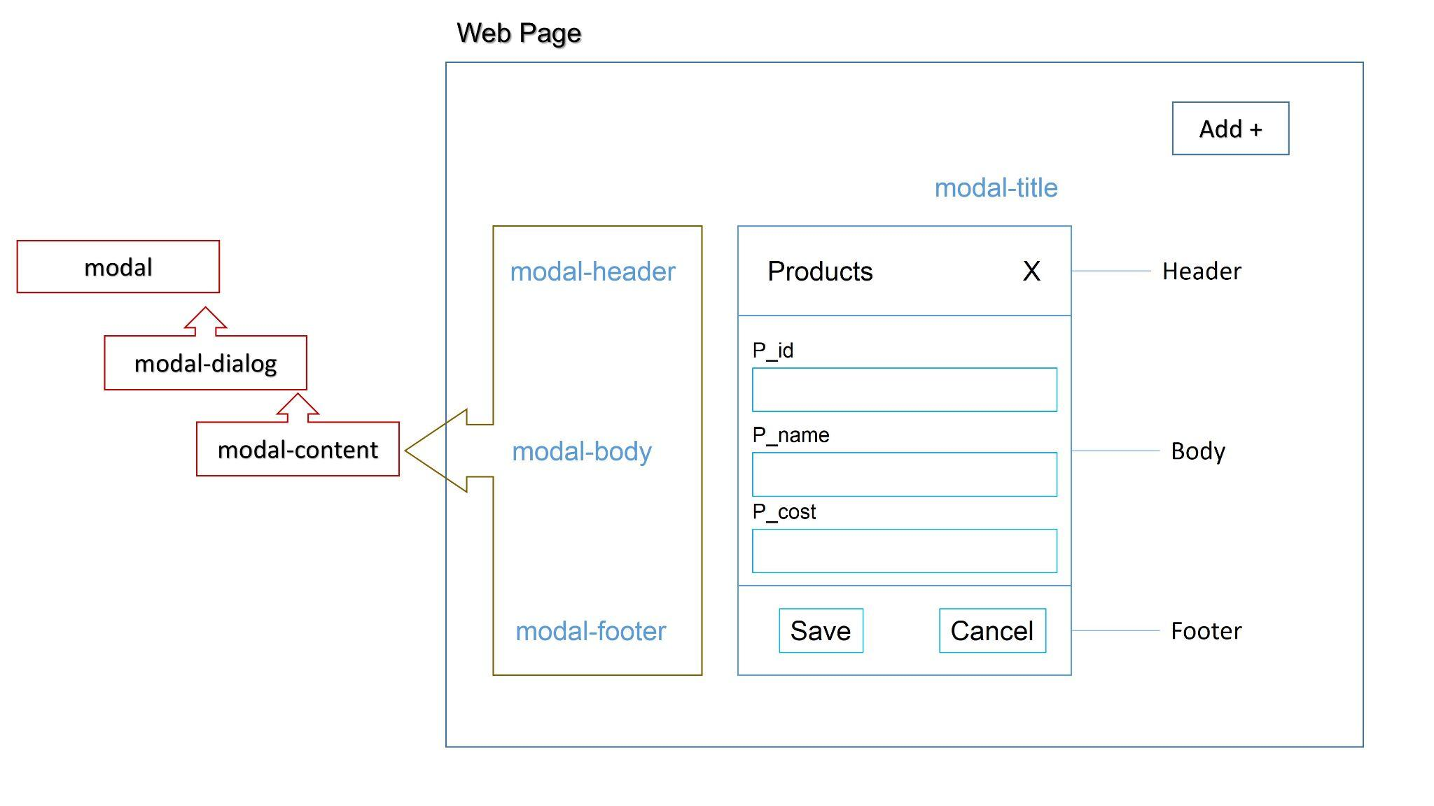

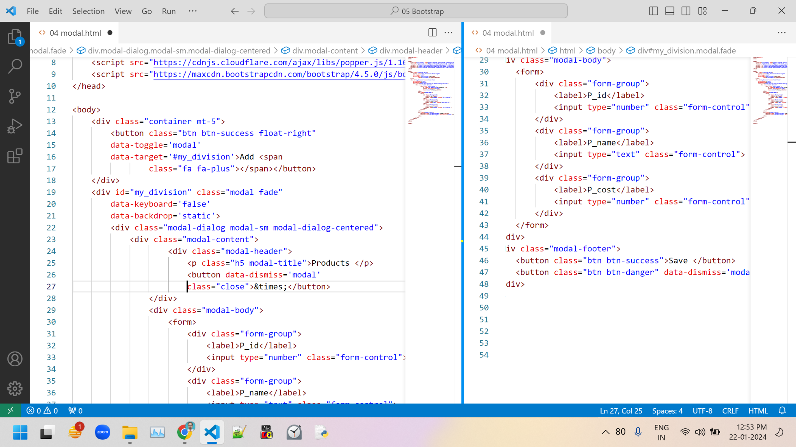

<div class="container mt-5">

<button class="btn btn-success float-right"

data-toggle='modal'

data-target='#my_division'>Add <span

class="fa fa-plus"></span></button>

</div>

<div id="my_division" class="modal fade"

data-keyboard='false'

data-backdrop='static'>

<div class="modal-dialog modal-sm modal-dialog-centered">

<div class="modal-content">

<div class="modal-header">

<p class="h5 modal-title">Products </p>

<button data-dismiss='modal'

class="close">&times;</button>

</div>

<div class="modal-body">

<form>

<div class="form-group">

<label>P_id</label>

<input type="number" class="form-control">

</div>

<div class="form-group">

<label>P_name</label>

<input type="text" class="form-control">

</div>

<div class="form-group">

<label>P_cost</label>

<input type="number" class="form-control">

</div>

</form>

</div>

<div class="modal-footer">

<button class="btn btn-success">Save </button>

<button class="btn btn-danger" data-dismiss='modal'>Cancel</button>

</div>

</div>

</div>

</div>

================================================================

Tables

================================================================

margins ml mr mt mb

mx my

m

padding pl pr pt pb

px py

p

Here for both min value 0

max value 5

classes

table

table-bordered

table-borderless

table-sm md lg

table-hover

table-*...*

<body>

<div class="container mt-5">

<button class="btn btn-success float-right mb-2 btn-sm">Add <span class="fa fa-plus"></span></button>

<table class="table

table-bordered

table-dark

table-hover

table-striped

table-sm">

<thead>

<tr>

<th>Sr no</th>

<th>P_id</th>

<th>P_name</th>

<th>P_cost</th>

<th>Edit</th>

<th>Delete</th>

</tr>

<tbody>

<tr>

<td>1</td>

<td>111</td>

<td>P_one</td>

<td>10000</td>

<td><span class="fa fa-edit text-warning"></span></td>

<td><span class="fa fa-trash text-danger"></span></td>

</tr>

<tr>

<td>2</td>

<td>222</td>

<td>P_two</td>

<td>20000</td>

<td><span class="fa fa-edit text-warning"></span></td>

<td><span class="fa fa-trash text-danger"></span></td>

</tr>

<tr>

<td>3</td>

<td>333</td>

<td>P_three</td>

<td>30000</td>

<td><span class="fa fa-edit text-warning"></span></td>

<td><span class="fa fa-trash text-danger"></span></td>

</tr>

<tr>

<td>4</td>

<td>444</td>

<td>P_four</td>

<td>40000</td>

<td><span class="fa fa-edit text-warning"></span></td>

<td><span class="fa fa-trash text-danger"></span></td>

</tr>

<tr>

<td>5</td>

<td>555</td>

<td>P_five</td>

<td>50000</td>

<td><span class="fa fa-edit text-warning"></span></td>

<td><span class="fa fa-trash text-danger"></span></td>

</tr>

</tbody>

</thead>

</table>

</div>

</body>

Input groups

Classes

input-group

input-group-sm md lg

input-group-prepend

input-group-append

input-group-text

<body>

<div class="container mt-5">

<div class="input-group my-3">

<div class="input-group-prepend">

<div class="input-group-text">₹</div>

</div>

<input type="text" class="form-control">

</div>

<div class="input-group my-3">

<input type="text" class="form-control">

<div class="input-group-append">

<div class="input-group-text">@tcs.com</div>

</div>

</div>

<div class="input-group my-3">

<div class="input-group-prepend">

<div class="input-group-text">₹</div>

</div>

<input type="text" class="form-control">

<div class="input-group-append">

<div class="input-group-text">.00</div>

</div>

</div>

<div class="input-group my-3 input-group-sm">

<div class="input-group-prepend">

<div class="input-group-text">₹</div>

</div>

<input type="text" class="form-control">

<div class="input-group-append">

<div class="input-group-text">.00</div>

</div>

</div>

<div class="input-group my-3 input-group-md">

<div class="input-group-prepend">

<div class="input-group-text">₹</div>

</div>

<input type="text" class="form-control">

<div class="input-group-append">

<div class="input-group-text">.00</div>

</div>

</div>

<div class="input-group my-3 input-group-lg">

<div class="input-group-prepend">

<div class="input-group-text">₹</div>

</div>

<input type="text" class="form-control">

<div class="input-group-append">

<div class="input-group-text">.00</div>

</div>

</div>

<div class="input-group my-3 input-group-lg">

<div class="input-group-prepend">

<div class="input-group-text">₹</div>

</div>

<input type="text" class="form-control">

<input type="text" class="form-control">

<div class="input-group-append">

<div class="input-group-text">.00</div>

</div>

</div>

<div class="input-group my-3 input-group-lg">

<div class="input-group-prepend">

<div class="input-group-text">₹</div>

</div>

<input type="text" class="form-control">

<input type="text" class="form-control">

<div class="input-group-append">

<div class="input-group-text bg-danger text-white">.00</div>

</div>

</div>

</div>

</body>

POC

Create informative website using HTML and CSS and Bootstrap for

Group of hotels

Group of Institutions

Group of Hospitals

- Choose any one

Design minimum 10 + 1 home pages

Application should contain

1. Basic information 🡪 done

2. About, Contact,🡪 done , Portfolio pages🡪 left

3. various departments and subdepartments 🡪 done

4. Back and home buttons / links

5. Common Headers and footers🡪 done

Use various images, attractive backgrounds 🡪done

scrolling text and images

enhancement 🡪 zoom on hover

For hint may refer

https://www.apollohospitals.com/

https://www.tajhotels.com/

https://www.paruluniversity.ac.in/

https://www.oberoihotels.com/

https://sanjivani.org.in/

https://sahyadrihospital.com/

================================================================

================================================================